Quaker Hill Country Club

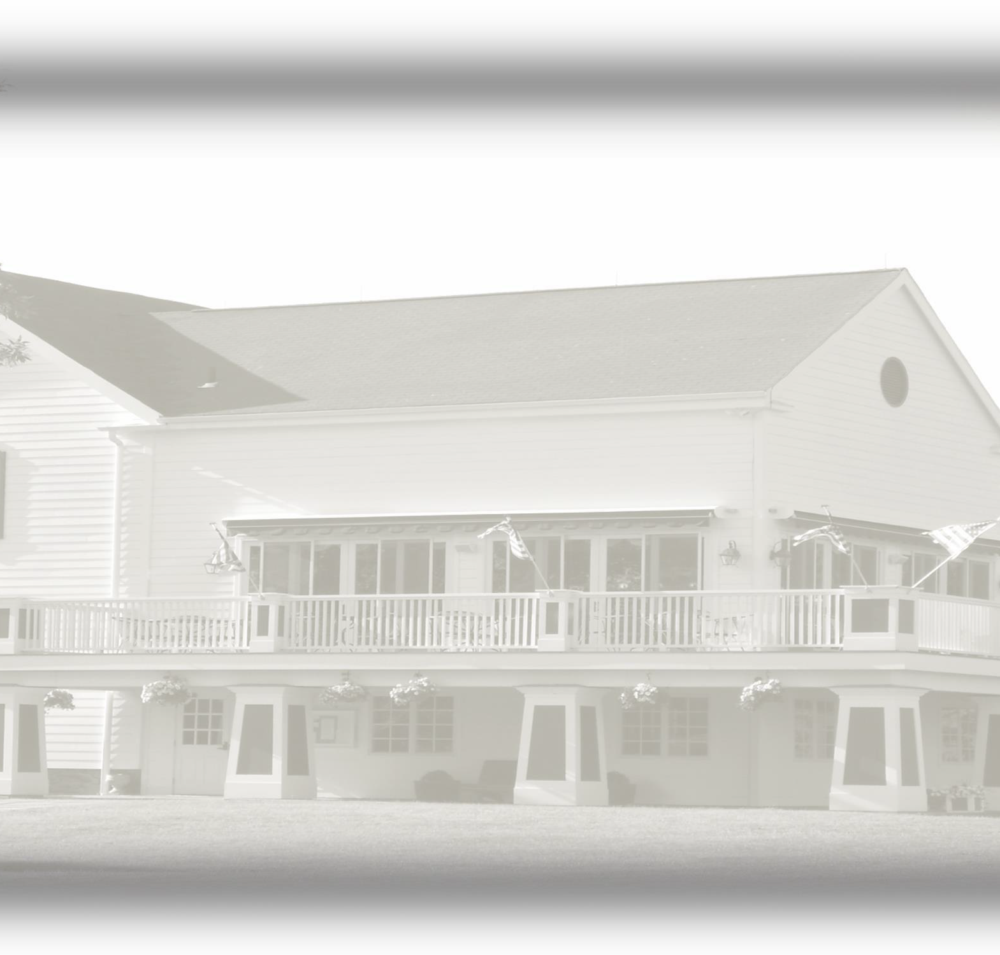

Membership Classification and Privileges

|  |  |  |  |
| --- | --- | --- | --- |
| **Membership Category** | **Membership Privileges** | **Initiation\*** | **2024**  **Dues** |
| **Regular Golf** | Entitled to all the privileges of the Club including use of the dining facilities, golf course, tennis courts, and croquet court. **,** | $12,000 over 2 years **\* 2024 Promotion $9500 if paid up**  **front** | $7,100 |
| **Regular Tennis** | Entitled to all the privileges of the Club,  except that their use of the golf course shall be restricted. | $3,500 | $3,550 |
| **Regular House** | Entitled to all the social and dining privileges of the Club. Their use of the golf course and the tennis courts is restricted. | $1,500 | $2,485 |
| **Junior Golf** | Restricted play Monday thru 2:00pm Friday. Jr. Members and Parents required to meet with golf professional and receive certification to play |  | $1,440 |
| **Intermediate Golf** | Entitled to all the privileges of a Regular Golf Member. Age 23-26  Age 27-30  Age 31-34 | $5000  $5000  $5000 | $2,370  $3,550  $5,320 |
| **Mid-Week Golf** | Entitled to all the social and dining privileges of the Club. Use of the golf course, driving range and tennis courts for this Class shall be restricted to Monday after 1pm until 2pm Friday. | $3,500 | $5,690 |
| **Intermediate Tennis** | Entitled to all the privileges of a Regular Tennis Member. Age 23-26  Age 27-30  Age 31-34 | $1,750 | $1,185  $1,775  $2,665 |

**Member privileges are extended to the member, spouse, domestic partner or significant other and member’s**

**children under 23 years of age.**

* Prospective Member applications must be accompanied by a deposit equal to 1/2 the applicable initiation fee.
* There is an annual food and beverage minimum of $700.00 for all Members.
* Initiation, dues, and assessments subject to applicable sales tax.
* Membership subject to approval by the Board of Directors.
* A potential end-of-year assessment for budgetary shortfalls. (Historically $350.00-$400.00)
* All membership privileges and fees are governed by the Club’s Board of Directors.